AUGUST HOLIDAY ASSIGNMENT
GRADE 7 CHRISTIAN RELIGIOUS EDUCATION (CRE)
CBC EXAMINATION PAPER
Time: 1 Hour 30 Minutes
Marks: 50
Name: ___________________________Grade/Class: ____________________
Admission Number: ________________Date: ____________________________
Instructions
- Answer all questions.
- Section A carries 15 marks.
- Section B carries 35 marks.
SECTION A: MULTIPLE CHOICE QUESTIONS (15 MARKS)
Choose the correct answer.

1. Study the picture below and answer the question that follows.
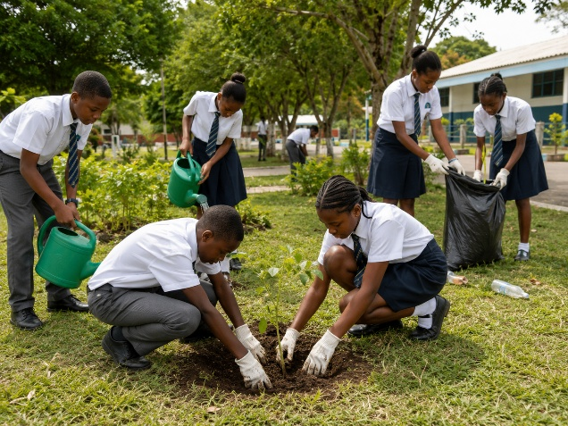The activity shown in the picture demonstrates:
A. Misuse of God’s creation
B. Stewardship over creation
C. Destruction of natural resources
D. Lack of responsibility
2. Study the picture below and answer the question that follows.
The activity shown promotes:
A. Understanding and applying God’s Word
B. Rejecting Christian teachings
C. Avoiding moral values
D. Ignoring religious guidance
3. Christian Religious Education is important because it helps learners to:
A. Develop good moral and religious values
B. Avoid responsibility in society
C. Reject community values
D. Promote harmful behaviours
4. According to the creation accounts in Genesis, human beings were created to:
A. Destroy the environment
B. Take care of God’s creation
C. Misuse natural resources
D. Harm other living things
5. Which one of the following is an attribute of God shown in the creation story?
A. Creator
B. Dishonest
C. Unkind
D. Weak
6. The two main divisions of the Bible are:
A. Books and Chapters
B. Old Testament and New Testament
C. Psalms and Proverbs
D. Gospels and Letters
7. The Bible is important in society today because it:
A. Guides people on righteous living
B. Encourages wrongdoing
C. Promotes hatred
D. Discourages good behaviour
8. One reason for translating the Bible into local languages is to:
A. Make it easier for people to understand God’s message
B. Prevent people from reading it
C. Remove Christian teachings
D. Stop worship activities
9. Moses demonstrated good leadership by:
A. Guiding the Israelites according to God’s instructions
B. Refusing to serve God
C. Ignoring the needs of people
D. Leading through dishonesty
10. John the Baptist prepared people for the coming of:
A. King David
B. Moses
C. Jesus Christ
D. King Solomon
11. The birth of Jesus Christ was announced to Mary by:
A. Angel Gabriel
B. Prophet Elijah
C. John the Baptist
D. King Herod
12. Baby Jesus was dedicated in the temple by:
A. Mary and Joseph
B. Peter and Paul
C. Moses and Aaron
D. David and Solomon
13. Human beings misuse natural resources when they:
A. Plant trees
B. Protect animals
C. Pollute rivers and destroy forests
D. Conserve the environment
14. A responsible Christian should demonstrate:
A. Integrity and respect
B. Selfishness and dishonesty
C. Hatred towards others
D. Carelessness
15. One lesson Christians learn from the childhood of Jesus is:
A. Obedience and respect for God
B. Disobedience to parents
C. Avoiding responsibility
D. Rejecting teachings

SECTION B: OPEN-ENDED QUESTIONS (35 MARKS)
Answer all questions.
16. Importance of Christian Religious Education (5 Marks)
a) Explain three reasons why learning Christian Religious Education is important. (3 marks)

b) State two Christian values that promote responsible living. (2 marks)

17. Creation and Stewardship (8 Marks)
a) Describe the two biblical accounts of creation. (4 marks)

b) Explain four ways human beings can demonstrate good stewardship over animals, birds, fish, and plants. (4 marks)

18. The Bible and Its Importance (8 Marks)
a) Identify the two divisions of the Bible. (2 marks)

b) Explain three ways the Bible promotes holistic growth among Christians. (3 marks)

c) State three reasons why the Bible has been translated into local languages. (3 marks)
19. Leadership in Israel (7 Marks)
a) Explain three ways God prepared Moses for leadership. (3 marks)

b) State four leadership qualities Christians can learn from Moses. (4 marks)

20. The Early Life of Jesus Christ (7 Marks)
a) Explain three Old Testament prophecies about the Messiah. (3 marks)

b) State two lessons Christians learn from John the Baptist’s teachings. (2 marks)

c) Mention two values learnt from the birth and childhood of Jesus Christ. (2 marks)

