AUGUST HOLIDAY ASSIGNMENT
GRADE 7 AGRICULTURE
CBC EXAMINATION PAPER
Time: 1 Hour 30 Minutes
Marks: 50
Name: ___________________________ Class: ___________ Date: ___________
Instructions
- Answer all questions.
- Section A has 15 marks.
- Section B has 35 marks.
SECTION A: MULTIPLE CHOICE QUESTIONS (15 MARKS)
Choose the correct answer. Each question carries one mark.

1. Study the picture below and answer the question that follows.
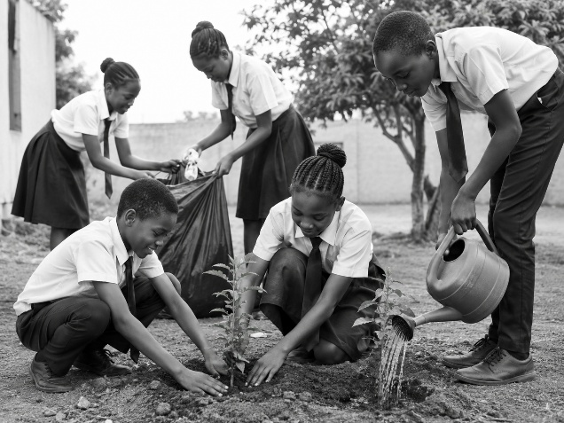The activity shown in the picture helps to:
A. Increase soil pollution
B. Conserve the environment
C. Destroy water sources
D. Reduce food production
2. Study the picture below and answer the question that follows.
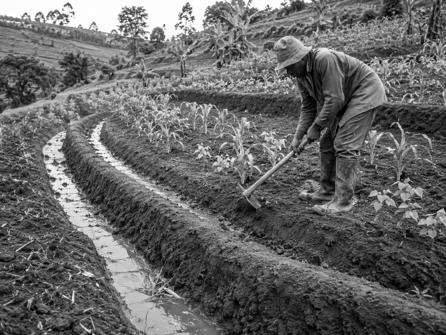The structure shown is mainly used to:
A. Increase soil erosion
B. Store surface runoff water
C. Remove nutrients from soil
D. Destroy Garden crops
3. Which one of the following is a cause of soil pollution in gardening?
A. Applying compost manure
B. Planting trees
C. Dumping plastics in the garden
D. Practising crop rotation
4. Which practice helps conserve vitamins and minerals in vegetables?
A. Overcooking vegetables
B. Washing vegetables after cutting
C. Using proper cooking methods
D. Throwing away vegetable leaves
5. The first step when preparing land for planting is to ensure that the soil has a suitable:
A. Colour
B. Tilth
C. Smell
D. Temperature
6. Which one of the following is a crop management practice?
A. Weeding
B. Knitting
C. Laundering
D. Cooking
7. Trees are important in the environment because they:
A. Increase soil erosion
B. Provide oxygen and prevent soil erosion
C. Reduce rainfall
D. Pollute water sources
8. Which method is suitable for cooking food using hot oil?
A. Boiling
B. Frying
C. Steaming
D. Roasting
9. Keeping animal houses clean helps to:
A. Spread diseases
B. Improve animal hygiene
C. Reduce animal production
D. Increase pests
10. A farmer prepares animal products mainly to:
A. Make them useful for different purposes
B. Destroy their value
C. Increase wastage
D. Prevent consumption
11. A loose-coloured cloth should be washed separately to prevent:
A. Shrinkage
B. Colour bleeding
C. Drying
D. Folding
12. Knitting involves using:
A. Needles and yarn
B. Seeds and soil
C. Water and manure
D. Knives and fire
13. A framed suspended garden is useful because it:
A. Saves space for crop production
B. Increases soil pollution
C. Prevents plant growth
D. Removes nutrients from crops
14. Surface runoff can be useful in gardening when it is:
A. Wasted away
B. Collected and stored
C. Mixed with waste
D. Allowed to cause erosion
15. Which one of the following shows responsibility in farming?
A. Using unsafe farming practices
B. Conserving soil and water resources
C. Destroying trees
D. Polluting the environment

SECTION B: OPEN-ENDED QUESTIONS (35 MARKS)
Answer all questions.
16. Controlling Soil Pollution (5 Marks)
a) Explain three causes of soil pollution in a home garden. (3 marks)
b) State two ways of controlling soil pollution. (2 marks)
17. Water Retention Structures (5 Marks)
a) What is surface runoff? (2 marks)
b) Describe three ways farmers can use surface runoff in gardening. (3 marks)
18. Food Production Processes (10 Marks)
a) Explain the importance of preparing a suitable tilth before planting crops. (4 marks)
b) Describe three crop management practices carried out after planting. (3 marks)
c) State three methods of cooking food. (3 marks)
19. Hygiene Practices (8 Marks)
a) Explain four hygiene practices followed when rearing domestic animals. (4 marks)
b) Describe the procedure of laundering a loose-coloured article safely. (4 marks)
20. Production Techniques and Environmental Conservation (7 Marks)
a) Explain three importance of trees in conserving the environment. (3 marks)
b) Describe the steps involved in constructing a framed suspended garden. (4 marks)
END OF PAPER

