AUGUST HOLIDAY ASSIGNMENT
GRADE 7 CHRISTIAN RELIGIOUS EDUCATION (CRE)
CBC EXAMINATION PAPER
Time: 1 Hour 30 Minutes
Marks: 50
Name: ___________________________Grade/Class: _____________________
Admission Number: ________________Date: ____________________________
Instructions
- Answer all questions.
- Section A carries 15 marks.
- Section B carries 35 marks.
SECTION A: MULTIPLE CHOICE QUESTIONS (15 MARKS)
Choose the correct answer.

1. Christian Religious Education is important because it helps learners to:
A. Develop good moral and religious values
B. Avoid responsibility in society
C. Reject teachings from the Bible
D. Ignore community values
2. Which one of the following shows good stewardship of God’s creation?
A. Destroying forests
B. Taking care of plants and animals
C. Polluting rivers
D. Wasting natural resources
3. Study the image below and answer the question that follows.
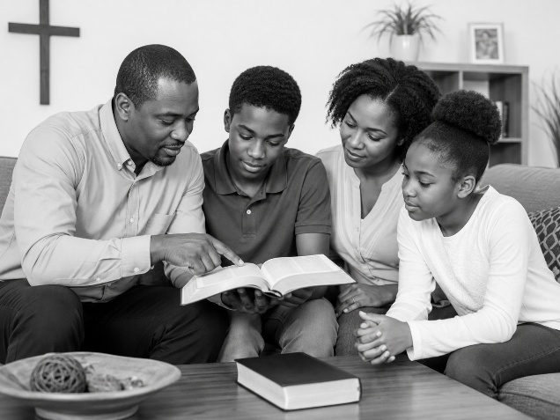The activity shown in the image demonstrates:
A. Bible study and spiritual growth
B. Ignoring God’s teachings
C. Refusing to worship
D. Avoiding Christian values
4. The two main divisions of the Bible are:
A. Psalms and Proverbs
B. Old Testament and New Testament
C. Gospels and Letters
D. Chapters and verses
5. Which one of the following is an attribute of God shown in the creation accounts?
A. Creator
B. Dishonest
C. Weak
D. Unkind
6. Study the image below and answer the question that follows.
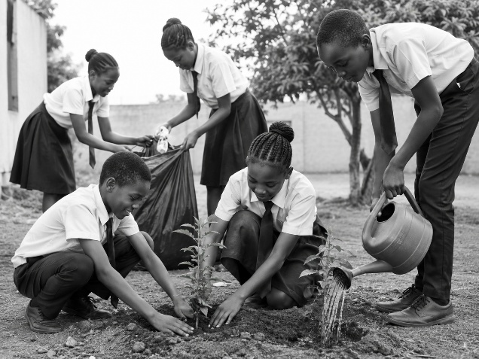The activity shown represents:
A. Destruction of creation
B. Environmental stewardship
C. Misuse of natural resources
D. Environmental pollution
7. Moses is remembered as a great leader because he:
A. Led the Israelites according to God’s instructions
B. Refused to serve God
C. Ignored the Israelites
D. Encouraged disobedience
8. The Bible was translated into local languages mainly to:
A. Make God’s Word easier for people to understand
B. Prevent people from reading it
C. Remove biblical teachings
D. Stop Christian worship
9. John the Baptist prepared people for the coming of:
A. King Solomon
B. Jesus Christ
C. Moses
D. King David
10. Study the image below and answer the question that follows.
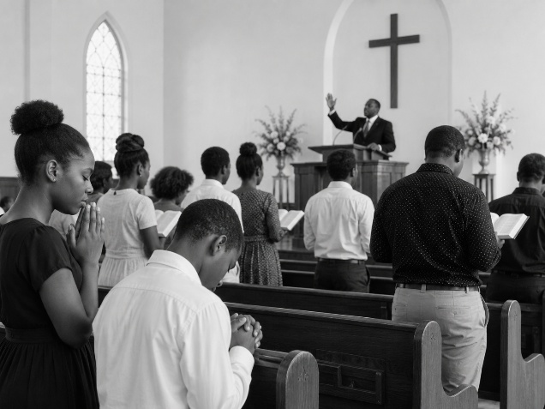The activity shown is an example of:
A. Worship
B. Trade
C. Farming
D. Entertainment
11. Baby Jesus was dedicated in the temple by:
A. Mary and Joseph
B. Peter and Paul
C. Moses and Aaron
D. David and Solomon
12. Human beings misuse natural resources when they:
A. Conserve the environment
B. Plant trees
C. Destroy forests and pollute water sources
D. Protect animals
13. The Church contributes to society through:
A. Providing education and health services
B. Promoting conflict
C. Preventing learning
D. Discouraging community service
14. Study the image below and answer the question that follows.
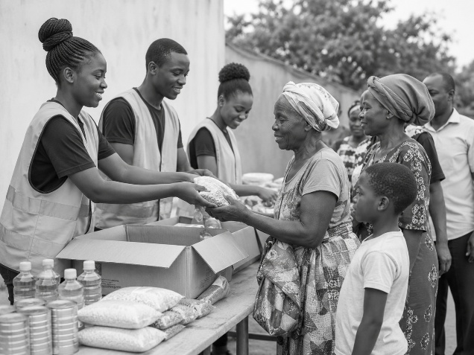The activity shown demonstrates:
A. Church service to the community
B. Competition among believers
C. Religious conflict
D. Personal gain only
15. A healthy relationship is based on:
A. Respect and responsibility
B. Dishonesty and disrespect
C. Violence and pressure
D. Lack of communication

SECTION B: OPEN-ENDED QUESTIONS (35 MARKS)
Answer all questions.
16. Importance of Christian Religious Education (5 Marks)
a) Explain three ways Christian Religious Education promotes responsible living. (3 marks)

b) State two Christian values that learners should practise daily. (2 marks)

17. Creation and Stewardship (8 Marks)
a) Describe the two biblical accounts of creation. (4 marks)

b) Explain four ways human beings can protect God’s creation. (4 marks)

18. The Bible and Leadership in Israel (8 Marks)
a) Identify the two divisions of the Bible. (2 marks)

b) Explain three reasons why the Bible is important in society today. (3 marks)

c) State three leadership qualities learnt from Moses. (3 marks)

19. Early Life of Jesus Christ (7 Marks)
a) Explain three Old Testament prophecies about the Messiah. (3 marks)

b) State two lessons learnt from John the Baptist’s teachings. (2 marks)

c) Mention two values learnt from the birth and childhood of Jesus Christ. (2 marks)

20. Worship and Christian Living Today (7 Marks)
a) Explain three importance of prayer and fasting among Christians. (3 marks)

b) State two contributions of the Church towards education and health. (2 marks)

c) Mention two values that help young people avoid irresponsible sexual behaviour. (2 marks)

