AUGUST HOLIDAY ASSIGNMENT
GRADE 7 CREATIVE ARTS AND SPORTS
CBC EXAMINATION PAPER
Time: 1 Hour 30 Minutes
Marks: 50
Name: ___________________________
Grade/Class: _____________________
Admission Number: ________________
Date: ____________________________
Instructions
- Answer all questions.
- Section A carries 15 marks.
- Section B carries 35 marks.
SECTION A: MULTIPLE CHOICE QUESTIONS (15 MARKS)
Choose the correct answer.

1. Study the image below and answer the question that follows.
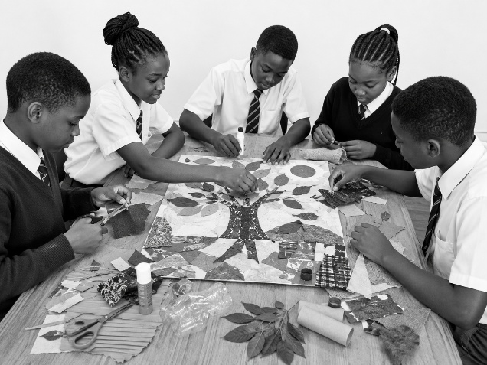The activity shown demonstrates:
A. Creative arts composition
B. Football training
C. Swimming skills
D. Music performance
2. Study the image below and answer the question that follows.
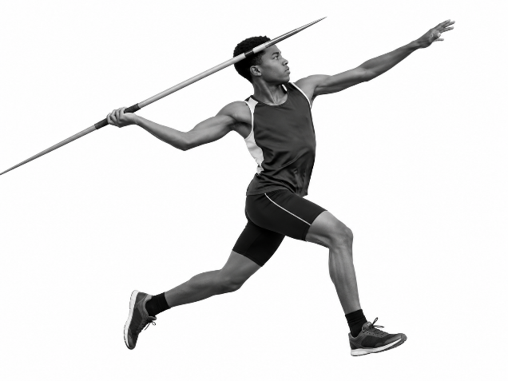The skill shown in the image is:
A. Handball passing
B. Javelin throwing
C. Football dribbling
D. Swimming dive
3. Creative Arts and Sports are important because they help learners to develop:
A. Creativity and physical skills
B. Laziness and dependence
C. Fear of participation
D. Poor communication
4. The three main categories of Creative Arts include:
A. Music, drama and visual arts
B. Farming, business and trade
C. Science, mathematics and languages
D. Reading, writing and calculation
5. Balance in a picture refers to:
A. Equal arrangement of visual elements
B. Using only one colour
C. Drawing without planning
D. Making a picture unclear
6. Warm colours include:
A. Blue and green
B. Red and orange
C. Purple and black
D. White and grey
7. A treble staff is used in music to show:
A. Pitches and musical notes
B. Football positions
C. Swimming styles
D. Drawing techniques
8. Which one of the following is a handball skill?
A. Dribbling
B. Painting
C. Carving
D. Beading
9. A good melody should have:
A. A clear and pleasant arrangement of sounds
B. Random sounds without order
C. Only loud sounds
D. No rhythm
10. Storytelling can be made interesting through:
A. Good voice expression and creativity
B. Speaking without preparation
C. Avoiding audience interaction
D. Using unclear ideas
11. A flipbook animation works by:
A. Showing a sequence of pictures that create movement
B. Painting one picture only
C. Removing all images
D. Writing only words
12. Kenyan folk songs are important because they:
A. Preserve culture and traditions
B. Destroy cultural practices
C. Prevent communication
D. Discourage teamwork
13. Beadwork in Kenyan communities is used for:
A. Making jewellery and cultural items
B. Destroying materials
C. Playing football
D. Swimming activities
14. In football, trapping means:
A. Controlling the ball when receiving it
B. Throwing the ball away
C. Holding an opponent
D. Stopping the match
15. A safe water entry technique in swimming is important because it:
A. Prevents injuries and improves swimming skills
B. Makes swimming dangerous
C. Stops body movement
D. Prevents learning

SECTION B: OPEN-ENDED QUESTIONS (35 MARKS)
Answer all questions.
16. Foundations of Creative Arts and Sports (5 Marks)
a) Describe three categories of Creative Arts and Sports. (3 marks)

b) Explain two ways Creative Arts and Sports benefit learners. (2 marks)

17. Drawing, Painting and Music (8 Marks)
a) Explain three factors to consider when creating a balanced picture. (3 marks)

b) Describe the difference between warm and cool colours. (2 marks)

c) State three qualities of a good melody. (3 marks)

18. Performing Arts and Storytelling (8 Marks)
a) Explain four techniques used in effective storytelling. (4 marks)

b) Describe four qualities of a good flipbook animation. (4 marks)

19. Sports Skills (7 Marks)
a) Describe three skills used in a handball game. (3 marks)

b) Explain the phases involved in performing a javelin throw. (4 marks)

20. Kenyan Culture and Creative Skills (7 Marks)
a) Explain three functions of jewellery in Kenyan communities. (3 marks)

b) Describe four materials that can be used in beadwork. (4 marks)

