AUGUST HOLIDAY ASSIGNMENT
GRADE 7 INTEGRATED SCIENCE
CBC EXAMINATION PAPER
Time: 1 Hour 30 Minutes
Marks: 50
Name: ___________________________Grade/Class: _____________________
Admission Number: ________________Date: ____________________________
Instructions
- Answer all questions.
- Section A carries 15 marks.
- Section B carries 35 marks.
SECTION A: MULTIPLE CHOICE QUESTIONS (15 MARKS)
Choose the correct answer.

1. Integrated Science is important in daily life because it helps learners to:
A. Understand and solve problems using scientific knowledge
B. Avoid asking scientific questions
C. Ignore environmental issues
D. Depend only on traditional beliefs
2. Which one of the following is a laboratory hazard?
A. Wearing protective clothing
B. Broken glass apparatus
C. Proper storage of chemicals
D. Following safety instructions
3. Study the image below and answer the question that follows.
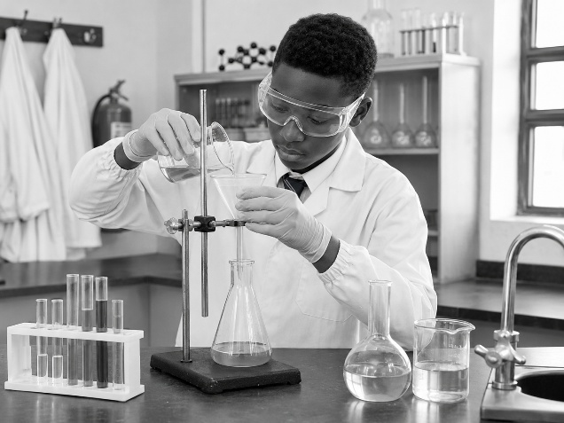The activity shown is used to identify:
A. The mass of a substance
B. Whether a substance is acidic or basic
C. The temperature of a substance
D. The volume of a liquid
4. The SI unit used to measure mass is:
A. Metre
B. Second
C. Kilogram
D. Litre
5. Which method can be used to separate salt from salt solution?
A. Filtration
B. Evaporation
C. Sieving
D. Decanting
6. During adolescence, boys and girls experience:
A. Physical and emotional changes
B. Complete physical inactivity
C. No body development
D. Loss of body functions
7. The main function of the urinary system is to:
A. Remove waste products from the body
B. Produce oxygen
C. Control body temperature
D. Digest food
8. Study the image below and answer the question that follows.
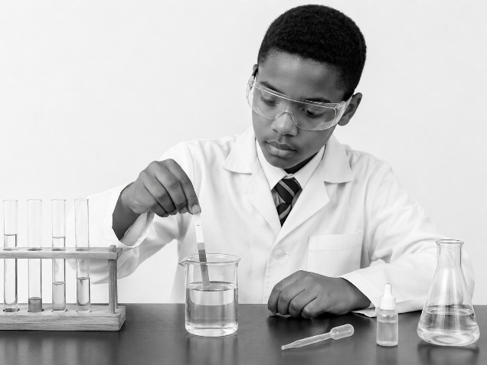The learner is practising:
A. Laboratory safety
B. Unsafe experimentation
C. Improper handling of apparatus
D. Chemical wastage
9. Which one of the following is a part of the female reproductive system?
A. Testis
B. Ovary
C. Sperm duct
D. Penis
10. A substance that changes colour when added to an acid or base is called:
A. Apparatus
B. Indicator
C. Solvent
D. Mixture
11. Which one of the following practices promotes kidney health?
A. Drinking adequate water
B. Avoiding all physical activities
C. Taking unknown medicines
D. Eating unhealthy foods regularly
12. A mixture is made up of:
A. Two or more substances physically combined
B. One pure element only
C. One compound only
D. A single atom
13. First Aid in the laboratory is important because it:
A. Provides immediate help after an accident
B. Replaces laboratory rules
C. Prevents all experiments
D. Removes the need for safety equipment
14. The skin helps the body by:
A. Protecting the body and regulating temperature
B. Producing digestive enzymes
C. Pumping blood
D. Producing hormones only
15. Which one of the following is an acid?
A. Soap solution
B. Lemon juice
C. Baking soda solution
D. Salt solution

SECTION B: OPEN-ENDED QUESTIONS (35 MARKS)
Answer all questions.
16. Introduction to Integrated Science (5 Marks)
a) Explain three importance of studying Integrated Science. (3 marks)

b) State two areas of science included in Integrated Science. (2 marks)

17. Laboratory Safety and Apparatus (8 Marks)
a) Identify four common laboratory hazards. (4 marks)

b) Explain four safety measures learners should observe in the laboratory. (4 marks)

18. Mixtures, Acids, Bases and Indicators (8 Marks)
a) Describe three methods used to separate mixtures. (3 marks)

b) Explain how litmus paper is used to identify acids and bases. (3 marks)

c) State two uses of acids and bases in daily life. (2 marks)

19. Human Reproductive System (7 Marks)
a) Name three parts of the male reproductive system. (3 marks)

b) Explain four physical changes that occur in boys and girls during adolescence. (4 marks)

20. Human Excretory System (7 Marks)
a) State three functions of the skin. (3 marks)

b) Explain two causes of kidney disorders. (2 marks)

c) State two ways of maintaining healthy kidneys. (2 marks)

