AUGUST HOLIDAY ASSIGNMENT
GRADE 7 MATHEMATICS
CBC EXAMINATION PAPER
Time: 1 Hour 30 Minutes
Marks: 50
Name: ___________________________Grade/Class: _____________________
Admission Number: ________________Date: ____________________________
Instructions
- Answer all questions.
- Section A carries 15 marks.
- Section B carries 35 marks.
SECTION A: MULTIPLE CHOICE QUESTIONS (15 MARKS)
Choose the correct answer.

1. The place value of the digit 5 in 456,782,910 is:
A. Hundreds
B. Millions
C. Ten millions
D. Thousands
2. Which one of the following numbers is a prime number?
A. 21
B. 35
C. 29
D. 51
3. Study the diagram below and answer the question that follows.
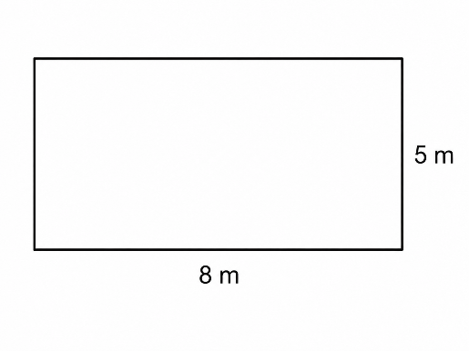
The length of the missing side can be found using:
A. Area formula
B. Pythagorean relationship
C. Circumference formula
D. Volume formula
4. The LCM of 4 and 6 is:
A. 24
B. 10
C. 12
D. 2
5. Which fraction is equivalent to 1/2?
A. 2/4
B. 3/5
C. 4/5
D. 5/6
6. Solve the equation:
3x + 5 = 20
A. x = 10
B. x = 5
C. x = 15
D. x = 25
7. Study the image below and answer the question that follows.
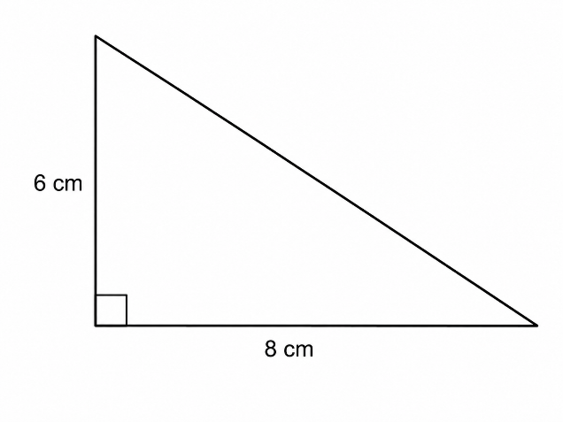The area of the garden is:
A. 13 m²
B. 26 m²
C. 40 m²
D. 80 m²
8. Which one of the following is a correct inequality statement?
A. x + 2 = 5
B. x + 2 > 5
C. x + 2 × 5
D. x + 2 ≠
9. The square root of 144 is:
A. 10
B. 11
C. 12
D. 14
10. A car travels 120 km in 3 hours. Its speed is:
A. 40 km/h
B. 60 km/h
C. 30 km/h
D. 360 km/h
11. Which one of the following is a unit of volume?
A. Square metre
B. Cubic metre
C. Kilometre
D. Litre only
12. Study the pattern below.
2, 4, 6, 8, ___
The next number is:
A. 9
B. 10
C. 12
D. 14
13. The value of 2.5 × 4 is:
A. 1.0
B. 5.0
C. 10.0
D. 20.0
14. A circle has a radius of 7 cm. The measurement around the circle is called:
A. Area
B. Perimeter
C. Circumference
D. Volume
15. Which one of the following is a factor of 24?
A. 5
B. 6
C. 7
D. 11

SECTION B: OPEN-ENDED QUESTIONS (35 MARKS)
Answer all questions.
16. Whole Numbers and Factors (7 Marks)
a) Write 456,789,321 in words. (2 marks)

b) Round off 456,789,321 to the nearest hundred million. (2 marks)

c) Find the Greatest Common Divisor (GCD) of 18 and 24 using the factor method. (3 marks)

17. Fractions and Decimals (8 Marks)
a) Add: 2/5 + 1/5 (2 marks)

b) Multiply: 3/4 × 8 (2 marks)

c) Calculate: 4.5 × 3 (2 marks)

d) Arrange the following fractions from the smallest to the largest:
1/2, 3/4, 1/4 (2 marks)

18. Algebra (7 Marks)
a) Solve the equation: 5x - 8 = 17 (3 marks)

b) Write an inequality statement for the sentence:
"A number y is greater than 10." (2 marks)

c) Represent the inequality y > 10 on a number line. (2 marks)

19. Measurements (7 Marks)
a) A rectangle has a length of 12 cm and a width of 5 cm. Calculate its perimeter. (3 marks)

b) Convert 3 metres into centimetres. (2 marks)

c) A cyclist travels 60 km in 2 hours. Calculate the speed. (2 marks)

20. Area, Volume and Capacity (6 Marks)
a) Find the area of a rectangle measuring 8 m by 6 m. (2 marks)

b) State the unit used to measure volume. (2 marks)

c) A cuboid has a volume of 120 cm³. Explain what volume represents. (2 marks)

