AUGUST HOLIDAY ASSIGNMENT
GRADE 7 PRE-TECHNICAL STUDIES
CBC EXAMINATION PAPER
Time: 1 Hour 30 Minutes
Marks: 50
Name: ___________________________Grade/Class: _____________________
Admission Number: ________________Date: ____________________________
Instructions
- Answer all questions.
- Section A carries 15 marks.
- Section B carries 35 marks.
SECTION A: MULTIPLE CHOICE QUESTIONS (15 MARKS)
Choose the correct answer.

1. Pre-Technical Studies mainly involves learning about:
A. Technical skills, materials, tools, and production processes
B. Only games and entertainment
C. Farming activities only
D. Religious activities only
2. Which one of the following shows a safe practice in the working environment?
A. Leaving tools on the floor
B. Wearing protective clothing when required
C. Handling machines carelessly
D. Ignoring warning signs
3. Study the image below and answer the question that follows.
The items shown in the image are examples of:
A. Drawing instruments
B. Computer hardware devices
C. Measuring tools
D. Metallic materials
4. Drawing is important in Pre-Technical Studies because it helps learners to:
A. Communicate ideas and technical information
B. Avoid planning activities
C. Replace all practical work
D. Destroy materials
5. Which one of the following is a type of line used in technical drawing?
A. Zigzag line
B. Invisible idea
C. Sound line
D. Written line
6. Study the image below and answer the question that follows.
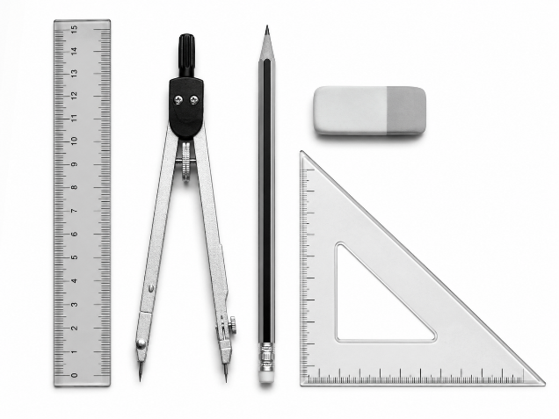The tools shown are mainly used for:
A. Measuring and marking out
B. Cooking and cleaning
C. Communication only
D. Storage of materials
7. Which one of the following is a metallic material?
A. Wood
B. Rubber
C. Aluminium
D. Plastic
8. ICT tools are useful in communication because they:
A. Make sharing information easier and faster
B. Prevent people from communicating
C. Replace all human interaction
D. Remove the need for messages
9. Which one of the following is a natural non-metallic material?
A. Copper
B. Steel
C. Wood
D. Aluminium
10. A free-hand sketch is produced by:
A. Drawing using only a computer
B. Drawing without relying on measuring instruments
C. Copying a machine-made drawing
D. Using only photographs
11. Study the image below and answer the question that follows.
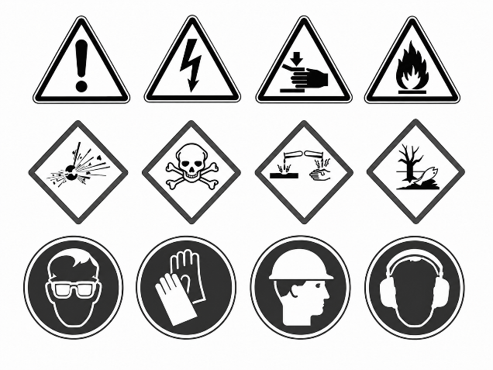The symbols shown are important because they:
A. Help identify safety requirements and hazards
B. Decorate the workshop
C. Replace all tools
D. Increase accidents
12. Which one of the following is an output device of a computer?
A. Keyboard
B. Mouse
C. Monitor
D. Scanner
13. Metallic materials are suitable for production because they often have:
A. Strength and durability
B. No useful properties
C. Ability to disappear easily
D. Complete weakness
14. Study the image below and answer the question that follows.
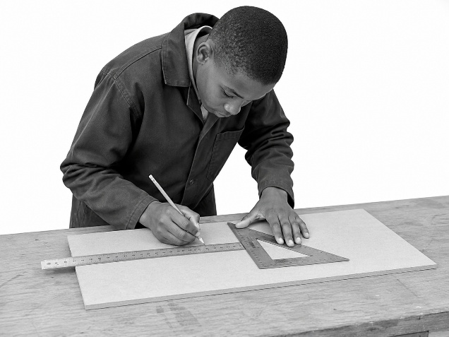The tools shown are mainly used for:
A. Technical drawing activities
B. Cooking activities
C. Farming activities
D. Washing activities
15. Proper storage of tools is important because it:
A. Prevents damage and improves safety
B. Makes tools unavailable
C. Causes accidents
D. Reduces the lifespan of tools

SECTION B: OPEN-ENDED QUESTIONS (35 MARKS)
Answer all questions.
16. Foundations of Pre-Technical Studies (5 Marks)
a) Explain three roles of Pre-Technical Studies in everyday life. (3 marks)

b) State two careers related to Pre-Technical Studies. (2 marks)

17. Safety in the Immediate Environment (8 Marks)
a) Identify four safety hazards that may occur in a workshop or learning environment. (4 marks)

b) Explain four safety measures that should be followed when using tools and equipment. (4 marks)

18. Drawing and Communication (8 Marks)
a) Explain three reasons why drawing is used as a means of communication. (3 marks)

b) Describe three principles of free-hand sketching. (3 marks)

c) State two types of drawings used in technical fields. (2 marks)

19. Materials for Production (7 Marks)
a) Name three metallic materials found in the local environment. (3 marks)

b) Explain two physical properties of metallic materials. (2 marks)

c) State two examples of non-metallic materials. (2 marks)

20. Tools and Computer Hardware (7 Marks)
a) Identify three measuring and marking out tools. (3 marks)

b) Explain two reasons why computer hardware devices are important. (2 marks)

c) State two ways of caring for tools and equipment. (2 marks)

