AUGUST HOLIDAY ASSIGNMENT
GRADE 7 SOCIAL STUDIES
CBC EXAMINATION PAPER
Time: 1 Hour 30 Minutes
Marks: 50
Name: ___________________________Grade/Class: _____________________
Admission Number: ________________Date: ____________________________
Instructions
- Answer all questions.
- Section A carries 15 marks.
- Section B carries 35 marks.
SECTION A: MULTIPLE CHOICE QUESTIONS (15 MARKS)
Choose the correct answer.

1. Social Studies is important because it helps learners to:
A. Understand society and solve social problems
B. Avoid participating in community activities
C. Ignore cultural practices
D. Prevent personal development
2. Study the image below and answer the question that follows.
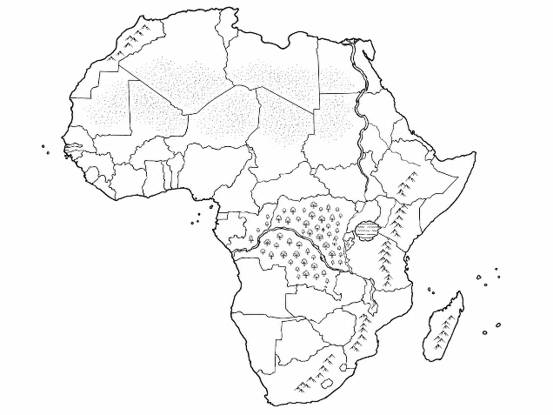The image shown is useful in Social Studies because it helps learners to:
A. Identify locations and countries
B. Measure body temperature
C. Study human organs
D. Identify farm tools
3. Which one of the following is a source of historical information?
A. Oral traditions
B. Mobile phones only
C. Modern buildings only
D. Weather instruments only
4. The Earth is part of the:
A. Solar system
B. Ocean system
C. Weather station
D. Population system
5. Study the image below and answer the question that follows.
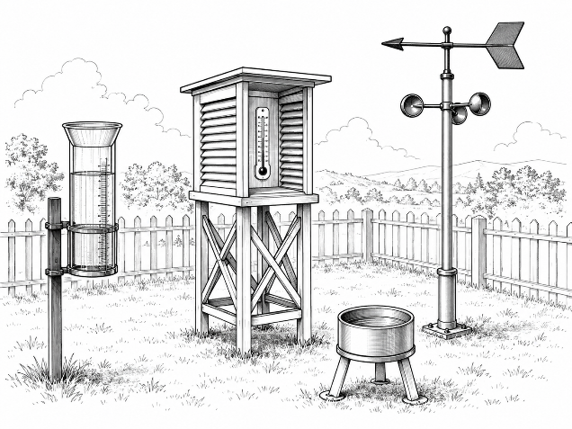The instruments shown are used to measure:
A. Weather elements
B. Population size
C. Historical events
D. Economic activities
6. Human diversity means:
A. Differences among people in society
B. All people being exactly the same
C. Avoiding interaction with others
D. Rejecting cultural identity
7. Which one of the following contributed to the growth of early African kingdoms?
A. Trade and agriculture
B. Lack of resources
C. Isolation from communities
D. Destruction of settlements
8. Study the image below and answer the question that follows.
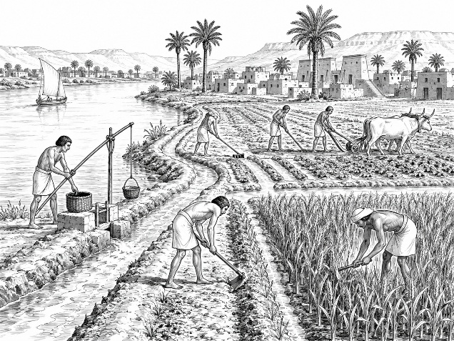The activity shown demonstrates:
A. Early agricultural practices
B. Modern computer technology
C. Industrial production
D. Political organisation
9. The main purpose of fieldwork in Social Studies is to:
A. Collect and analyse information from the environment
B. Avoid research activities
C. Replace classroom learning completely
D. Prevent observation
10. Which one of the following is a sustainable way of using resources?
A. Conserving forests and water
B. Wasting natural resources
C. Destroying wildlife habitats
D. Polluting the environment
11. Study the image below and answer the question that follows.
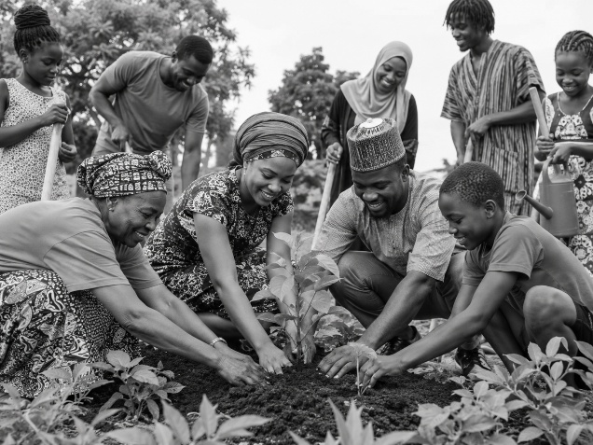The activity shown promotes:
A. Social cohesion and inclusion
B. Discrimination
C. Conflict among communities
D. Cultural isolation
12. The Indian Ocean slave trade involved the:
A. Forced movement and selling of Africans
B. Development of modern industries
C. Growth of agriculture only
D. Building of schools only
13. The Berlin Conference of 1884–1885 was mainly concerned with:
A. Partition of Africa among European powers
B. Formation of African kingdoms
C. Development of African agriculture
D. Establishment of weather stations
14. Which one of the following is an example of an economic activity?
A. Farming
B. Sleeping
C. Playing games only
D. Greeting people
15. Money economy replaced barter trade because money:
A. Made exchange of goods and services easier
B. Prevented all trade activities
C. Reduced economic activities
D. Stopped production

SECTION B: OPEN-ENDED QUESTIONS (35 MARKS)
Answer all questions.
16. Career and Entrepreneurial Opportunities in Social Studies (5 Marks)
a) Explain three importance of studying Social Studies. (3 marks)

b) State two career opportunities related to Social Studies. (2 marks)

17. Maps, Earth and Weather (8 Marks)
a) Explain three uses of maps in daily life. (3 marks)

b) Describe two effects of rotation and revolution of the Earth. (2 marks)

c) State three elements of weather. (3 marks)

18. Historical Information and Early Civilizations (8 Marks)
a) Identify four sources of historical information. (4 marks)

b) Explain four contributions of early African civilizations to the modern world. (4 marks)

19. People and Population (7 Marks)
a) Explain three factors that influence population distribution in Africa. (3 marks)

b) Describe two forms of slavery and servitude in traditional African societies. (2 marks)

c) State two ways of promoting human inclusion in society. (2 marks)

20. Resources, Economic Activities and Governance (7 Marks)
a) Explain three benefits of sustainable use of resources. (3 marks)

b) State two factors that led to the presence of Europeans in Africa. (2 marks)

c) Explain two economic activities practised by African communities. (2 marks)

