AUGUST HOLIDAY ASSIGNMENT 2026
GRADE 9 AGRICULTURE
CBC Competency-Based Assessment
Learner's Name: | ______________________________________________
School: | ________________________________________________________
Date: | __________________________________________________________
Time: | 1 hour 30 minutes
Total Marks: | 50
Instructions
Answer all questions in Sections A and B.
- Section A has 15 multiple choice questions. Each question carries 1 mark.
- Section B has structured questions worth 35 marks.
- Write your answers clearly in the spaces provided.
- Where a diagram or picture is required, study it carefully before answering.

Section A: Multiple Choice Questions (15 Marks)
Choose the correct answer from A, B, C or D. Each question carries 1 mark.
1. Which method is most suitable for conserving forage to cope with drought?
A. Burning dry grass
B. Making hay
C. Overgrazing pasture
D. Leaving fodder in rain
2. Before making hay, the forage should mainly be allowed to
A. rot in a heap
B. dry to reduce moisture
C. soak in water
D. mix with soil
3. Which condition is most important when storing hay?
A. High moisture
B. Good ventilation
C. Direct rainfall
D. Contact with wet ground
4. One importance of conserving leftover food at home is to
A. increase wastage
B. reduce food wastage
C. encourage contamination
D. reduce hygiene
5. Leftover food should be stored in clean covered containers mainly to
A. make it heavier
B. prevent contamination
C. change its colour
D. attract insects
6. Integrated farming helps conserve resources because waste from one enterprise can
A. be ignored
B. pollute water
C. support another enterprise
D. reduce production
7. In an integrated farm, poultry droppings may be used as
A. organic manure
B. weeds
C. hay
D. cooking flour
8. Organic gardening mainly avoids the excessive use of
A. mulch
B. compost
C. synthetic chemicals
D. crop rotation
9. Which practice best improves soil fertility in an organic garden?
A. Adding compost manure
B. Removing all organic matter
C. Burning crop residues
D. Planting in bare soil
10. Before storing crop produce, a granary should first be
A. left dirty
B. cleaned and repaired
C. filled with wet crop
D. closed without checking
11. A good way of reducing spoilage in stored crop produce is to
A. store produce while wet
B. dry produce properly
C. mix it with rubbish
D. keep it on damp floors
12. Which type of flour mixture is commonly used to make pancakes?
A. Batter
B. Compost
C. Hay
D. Mulch
13. Cleaning waste disposal facilities at household level helps to
A. spread diseases
B. attract pests
C. prevent bad smell and diseases
D. increase waste
14. The picture shows dry forage tied in bundles and stored under a roof. What conservation method is shown?
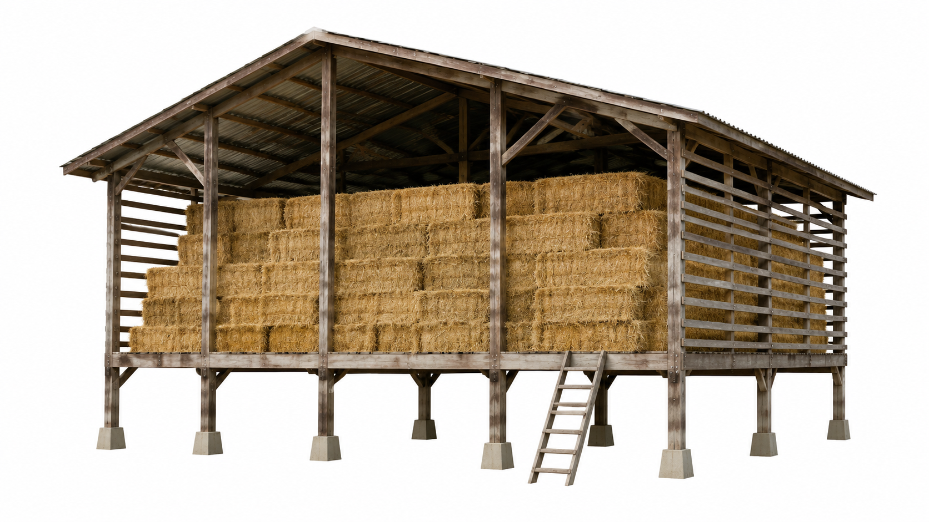

A. Silage making
B. Hay making
C. Composting
D. Mulching
15. The picture shows crop plants, poultry, fish pond and compost heap on one farm. What farming system is represented?
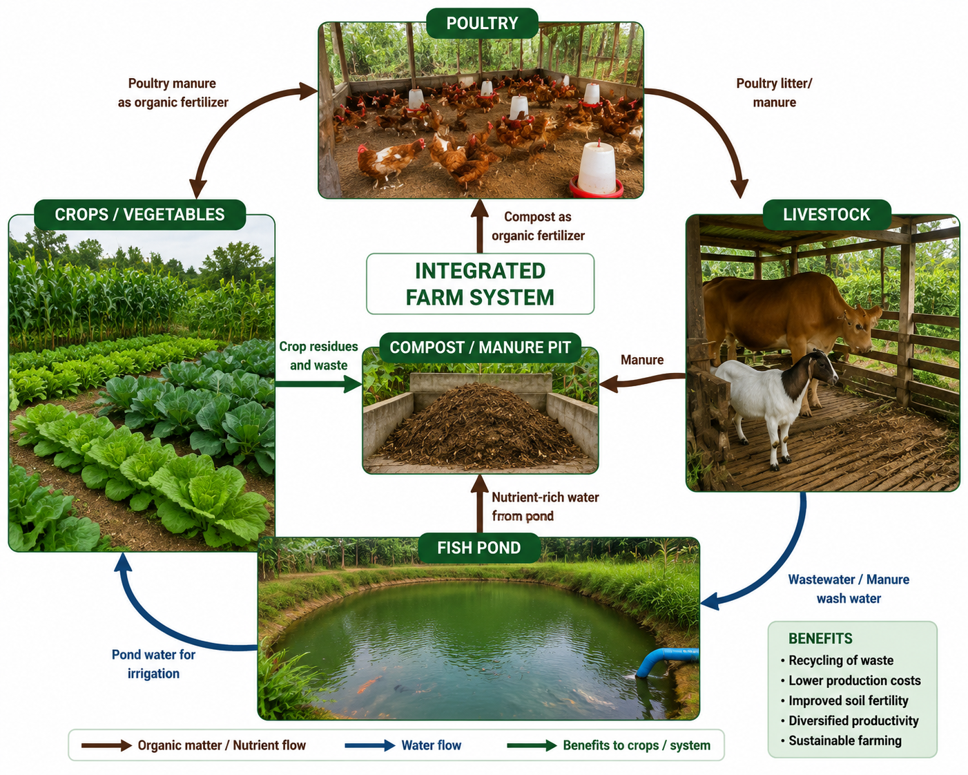

A. Monocropping
B. Integrated farming
C. Deforestation
D. Overgrazing

Section B: Open-Ended Questions (35 Marks)
Answer all questions. Show clear reasoning where required. Marks are shown in brackets.
16. Conserving Animal Feed: Hay (7 marks)
a) Describe three methods or practices used when conserving forage as hay. (3 marks)
________________________________________________________________________________
________________________________________________________________________________
b) A farmer stores hay while it is still damp. Explain two problems that may occur. (2 marks)
________________________________________________________________________________
________________________________________________________________________________
c) State two reasons why hay conservation helps farmers cope with drought. (2 marks)
________________________________________________________________________________
________________________________________________________________________________
17. Conserving Leftover Food (6 marks)
a) Give two reasons why leftover food should be conserved at home. (2 marks)
________________________________________________________________________________
________________________________________________________________________________
b) Describe two hygienic steps to follow when preparing leftover food for later use. (2 marks)
________________________________________________________________________________
________________________________________________________________________________
c) Your family has leftover ugali and vegetables after supper. Suggest two safe ways of using or storing them to avoid wastage. (2 marks)
________________________________________________________________________________
________________________________________________________________________________
18. Integrated Farming (7 marks)
a) Name four possible components of an integrated farm. (4 marks)
________________________________________________________________________________
________________________________________________________________________________
b) Explain how any two components can support each other in conserving resources. (2 marks)
________________________________________________________________________________
________________________________________________________________________________
c) State one value a learner develops by making a model of an integrated farm. (1 mark)
________________________________________________________________________________
19. Organic Gardening (6 marks)
a) Explain three organic gardening practices used in crop production. (3 marks)
________________________________________________________________________________
________________________________________________________________________________
b) A school wants to grow kales without relying on synthetic chemicals. Outline three actions learners should take. (3 marks)
________________________________________________________________________________
________________________________________________________________________________
20. Storage of Crop Produce (5 marks)
a) State three ways of preparing a storage structure before storing crop produce. (3 marks)
________________________________________________________________________________
________________________________________________________________________________
b) Give two ways of managing stored produce to reduce spoilage. (2 marks)
________________________________________________________________________________
________________________________________________________________________________
21. Hygiene Practices (4 marks)
a) Give two reasons for cleaning waste disposal facilities at household level. (2 marks)
________________________________________________________________________________
________________________________________________________________________________
b) State two methods used to disinfect clothing and household articles. (2 marks)
________________________________________________________________________________
________________________________________________________________________________

Teacher's Marking Guide - Section A
Answers: 1. B; 2. B; 3. B; 4. B; 5. B; 6. C; 7. A; 8. C; 9. A; 10. B; 11. B; 12. A; 13. C; 14. B; 15. B
Teacher's Note on Image Questions
Question 14 image: Use a clear hay-making image showing dried forage tied or baled and protected from rain.
Question 15 image: Use a labelled integrated farming diagram or real farm photo showing crops, animals, fish pond and compost/manure recycling.

